**PF Lab No 7**

**Name: Ali Rooman**

**Roll No: 24K-0792**

1. Write a C Program that takes an user input array and prints the sum of its elements.

Input: {1,2,3,4,5,6,7,8,9}

Output: 45

|  |
| --- |
| #include<stdio.h>  int main(){  int n,sum = 0;  printf("Enter size of integer array: ");  scanf("%d",&n);  int arr[n];  printf("Enter elements of array: ");  for(int i=0;i<=n;i++){  scanf("%d",&arr[i]);  }  printf("\n Elements of array are: ");  for(int i=0;i<=n;i++){  sum = sum + arr[i];  printf("%d\t",arr[i]);  }  printf("\n The sum of elements of array is: %d",sum);  return 0;  } |

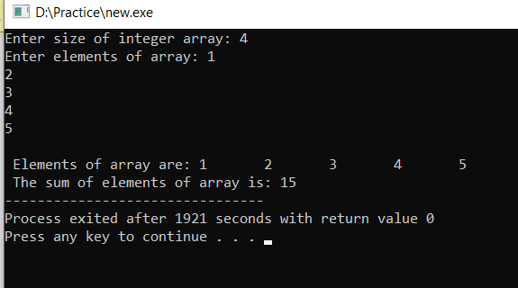OUTPUT

2. Write a program in C to read n number of values in an array and display it in reverse order

Input: {1,2,3,4,5,6,7,8,9}

Output: 9 8 7 6 5 4 3 2 1

|  |
| --- |
| #include<stdio.h>  int main(){  int n,sum = 0;  printf("Enter size of integer array: ");  scanf("%d",&n);  int arr[n];  printf("Enter elements of array: ");  for(int i=0;i<n;i++){  scanf("%d",&arr[i]);  }  printf("\n Elements of array are: ");  for(int i=n-1;i>=0;i--){  printf("%d\t",arr[i]);  }  return 0;  } |

OUTPUT

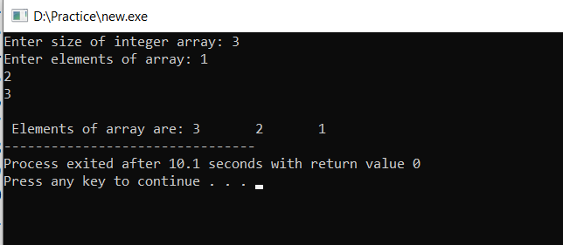

3. Write a C Program to find the minimum and maximum number in an array.

Input: {4,1,6,8,10,21,8,9,2,6}

Output:

Minimum Number = 1

Maximum Number = 21

|  |
| --- |
| #include <stdio.h>  int main() {  int n;  printf("Enter the number of elements: ");  scanf("%d", &n);  int arr[n];  printf("Enter %d elements:\n", n);  for(int i = 0; i < n; i++) {  scanf("%d", &arr[i]);  }  int min = arr[0];  int max = arr[0];  for(int i = 1; i < n; i++) {  if(arr[i] < min) {  min = arr[i];  }  if(arr[i] > max) {  max = arr[i];  }  }  printf("Minimum Number = %d\n", min);  printf("Maximum Number = %d\n", max);  return 0;  } |

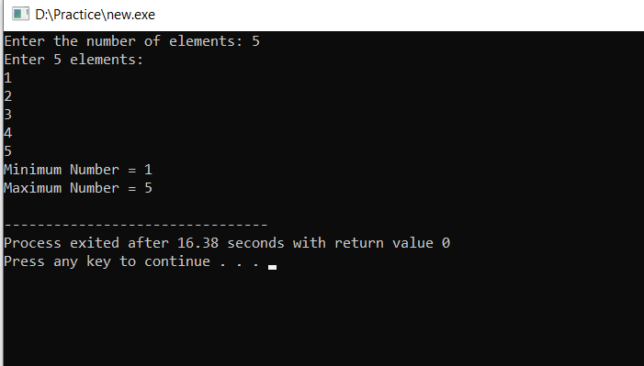OUTPUT

4. Given an array arr[] of size N which contains elements from 0 to N-1, you need to find all

the elements occurring more than once in the given array.

Input:

Array Size =5

Element 1=2

Element 2=3

Element 3=1

Element 4=2

Element 5=3

Output:

Number 2 and 3 in array occur more than once.

Note: You cannot utilize nested loops.

|  |
| --- |
| #include <stdio.h>  int main() {  int n;  printf("Enter the size of the array: ");  scanf("%d", &n);  int arr[n], freq[n];  for (int i = 0; i < n; i++) {  freq[i] = 0;  }  printf("Enter %d elements:\n", n);  for (int i = 0; i < n; i++) {  scanf("%d", &arr[i]);  freq[arr[i]]++;  }  printf("Numbers that occur more than once are: ");  int found = 0;  for (int i = 0; i < n; i++) {  if (freq[i] > 1) {  printf("%d ", i);  found = 1;  }  }  if (!found) {  printf("None");  }  return 0;  } |

OUTPUT

